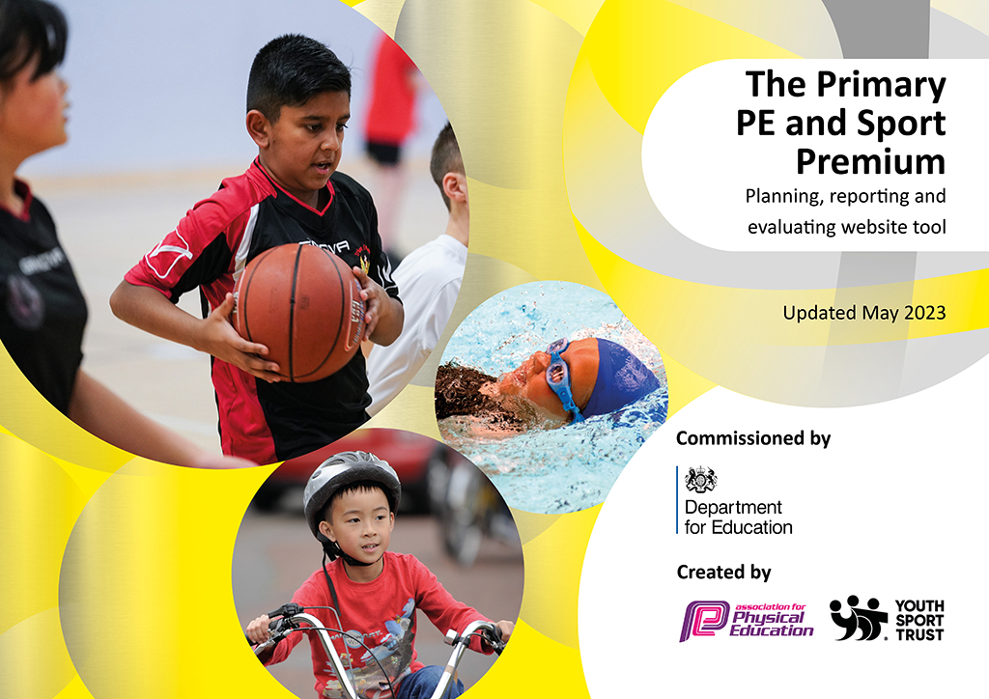
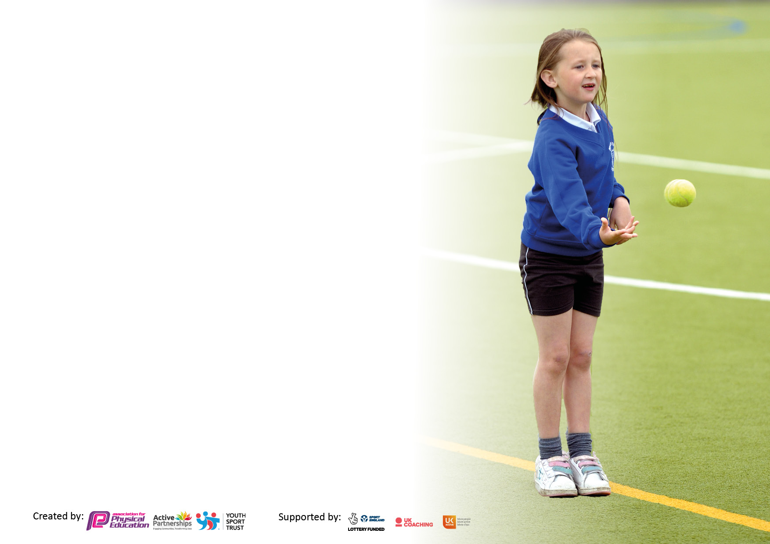

It is important that your grant is used effectively and based on school need. The Education Inspection Framework makes clear there will be a focus on ‘whether leaders and those responsible for governors all understand their respective roles and perform these in a way that enhances the effectiveness of the school’.

Under the Quality of Education Ofsted inspectors consider:
Intent - Curriculum design, coverage and appropriateness
Implementation - Curriculum delivery, Teaching (pedagogy) and Assessment
Impact - Attainment and progress

To assist schools with common transferable language this template has been developed to utilise the same three headings which should make your plans easily transferable between working documents.

Schools must use the funding to make additional and sustainable improvements to the quality of Physical Education, School Sport and Physical Activity (PESSPA) they offer. This means that you should use the Primary PE and sport premium to:

- Develop or add to the PESSPA activities that your school already offer
- Build capacity and capability within the school to ensure that improvements made now will benefit pupils joining the school in future years
- The Primary PE and sport premium should not be used to fund capital spend projects; the school’s budget should fund these.

Pleasevisitgov.ukfortherevisedDfEguidanceincludingthe5keyindicatorsacrosswhichschoolsshoulddemonstrate animprovement.Thisdocumentwillhelpyoutoreviewyourprovisionandtoreportyourspend.DfEencourage schools to use this template as an effective way of meeting the reporting requirements of the Primary PE and Sport Premium.

We recommend you start by reflecting on the impact of current provision and reviewing the previous spend.

Schools are required to publish details of how they spend this funding, including any under-spend from 2021/2022, as well as on the impact it has on pupils’ PE and sport participation and attainment. All funding must be spent by 31st July 2023.

We recommend regularly updating the table and publishing it on your website throughout the year. This evidences your ongoing self-evaluation of how you are using the funding to secure maximum, sustainable impact. Final copy must be posted on your website by the end of the academic year and no later than the 31st July 2023. To see an example of how to complete the table please click HERE.

Details with regard to funding
Please complete the table below.

Total amount carried over from 2021/22 | £0
Total amount allocated for 2021/22 | £ 9609
How much (if any) do you intend to carry over from this total fund into 2022/23? | £0
Total amount allocated for 2022/23 | £14733
Total amount of funding for 2022/23. To be spent and reported on by 31st July 2023. | £14733
Swimming Data
Please report on your Swimming Data below.

Meeting national curriculum requirements for swimming and water safety.  N.B. Complete this section to your best ability. For example you might have practised safe self-rescue techniques on dry land which you can then transfer to the pool when school swimming restarts.  Due to exceptional circumstances priority should be given to ensuring that pupils can perform safe self rescue even if they do not fully meet the first two requirements of the NC programme of study | NA
What percentage of your current Year 6 cohort swim competently, confidently and proficiently over a distance of at least 25 metres?  N.B. Even though your pupils may swim in another year please report on their attainment on leaving primary school at the end of the summer term 2022.  Please see note above | NA
What percentage of your current Year 6 cohort use a range of strokes effectively [for example, front crawl, backstroke and breaststroke]?  Please see note above | NA
What percentage of your current Year 6 cohort perform safe self-rescue in different water-based situations? | NA
Schools can choose to use the Primary PE and sport premium to provide additional provision for swimming but this must be for activity over and above the national curriculum requirements. Have you used it in this way? | No

Action Plan and Budget Tracking
Capture your intended annual spend against the 5 key indicators. Clarify the success criteria and evidence of impact that you intend to measure to evaluate for pupils today and for the future.

Academic Year: 2022/23 | Total fund allocated: | Date Updated:
Key indicator 1: The engagement of all pupils in regular physical activity – Chief Medical Officers guidelines recommend that primary school pupils undertake at least 30 minutes of physical activity a day in school |  |  |  | Percentage of total allocation:
 |  |  |  | 2%
Intent | Implementation |  | Impact
Your school focus should be clear what you want the pupils to know and be able to do and about  what they need to learn and to  consolidate through practice: | Make sure your actions to achieve are linked to your intentions: | Funding allocated: | Evidence of impact: what do pupils now know and what can they now do? What has changed? | Sustainability and suggested next steps:
To provide high quality games provision during lunchtime through Super Star Sports. | Sports Coach daily from 12-1.30pm to deliver range of sporting activities to improve skill and team work. | £225 per week  £8550 per year  Funding from hall hire charges | Improved skills of pupils.  Pupils able to work as a team and manage their feelings.  Encourage active lunch play in a structured way. | Continue with range of sporting activities throughout the year linked to sporting calendar e.g. Wimbledon etc.
Key indicator 2: The profile of PESSPA being raised across the school as a tool for whole school improvement |  |  |  | Percentage of total allocation:
 |  |  |  | 21%
Intent | Implementation |  | Impact
Your school focus should be clear what you want the pupils to know and be able to do and about  what they need to learn and to  consolidate through practice: | Make sure your actions to achieve are linked to your intentions: | Funding allocated: | Evidence of impact: what do pupils now know and what can they now do? What has changed? | Sustainability and suggested next steps:
To develop staff Skills in the delivery of quality PE | PE Leader to attend training / CPD – staff meeting time | £2500 LA PE membership  £600 – supply for LA courses | Staff updated and implement on new initiatives  Pupils attend LA events – multi-sports, Dance Festival Park events etc.  A wider variety of opportunities on offer.  Builds skills and capacity for staff and therefore pupils. | To continue to attend LA events  To continue to review progression documents -adopt new LA planning

Key indicator 3: Increased confidence, knowledge and skills of all staff in teaching PE and sport |  |  |  | Percentage of total allocation:
 |  |  |  | 77%
Intent | Implementation |  | Impact
Your school focus should be clear | Make sure your actions to | Funding | Evidence of impact: what do | Sustainability and suggested
what you want the pupils to know | achieve are linked to your | allocated: | pupils now know and what | next steps:
and be able to do and about | intentions: |  | can they now do? What has
what they need to learn and to |  |  | changed?:
consolidate through practice:
To use Dance specialist to support Dance skills  To use Gymnastics specialist to support Gymnastic skills | Dance teacher works in partnership with school staff to deliver Dance curriculum  Sport specialist to deliver Gymnastics to KS 1 | £11,400 | High level of engagement of pupils – Dance & Country Dance Festival  Opportunity for pupils to experience Dance from around the world – enrichment | Continue to develop dance opportunities – staff development  Consistency of delivery across each year group – best practice.
Key indicator 4: Broader experience of a range of sports and activities offered to all pupils |  |  |  | Percentage of total allocation:
Intent | Implementation |  | Impact
Your school focus should be clear | Make sure your actions to | Funding | Evidence of impact: what do | Sustainability and suggested
what you want the pupils to know | achieve are linked to your | allocated: | pupils now know and what | next steps:
and be able to do and about | intentions: |  | can they now do? What has
what they need to learn and to |  |  | changed?:
consolidate through practice:
Additional achievements:  Partnership with Super Star Sports – clubs delivered in school | Programme of sports offered including, Ninja skills for Reception, Gymnastics, multi-sports and football. | No cost.  Additional income for hire of hall space.  Additional income used to pay Lunchtime Sports coach. | More pupils accessing an improved variety of sports.  Encourages pupils to make friendships with other pupils in the school – teamwork. | To continue - activities evaluated and changed if needed.

Key indicator 5: Increased participation in competitive sport |  |  |  | Percentage of total allocation:
 |  |  |  | %
Intent | Implementation |  | Impact
Your school focus should be clear | Make sure your actions to | Funding | Evidence of impact: what do | Sustainability and suggested
what you want the pupils to know | achieve are linked to your | allocated: | pupils now know and what | next steps:
and be able to do and about | intentions: |  | can they now do? What has
what they need to learn and to |  |  | changed?:
consolidate through practice:
Multi- sports events at School supported by LA team for Year KS 1 pupils  Sport’s Day  Partnership with Super Star Sports – clubs delivered in school | Organise events- link with LA  Pupils to practice skills and take part in Sport’s Day  Advertise sporting opportunities with all pupils. | £ Cost in LA package  No cost  No cost | Pupils motivated by events – set personal best. “Be the best you can be!”  Inclusive opportunity for pupils to compete against others.  Opportunity for pupils to develop ball skills | Continue to engage with high quality sporting opportunities  Introduce personal best - running club  Programme to continue

Signed off by
Head Teacher: | VS Mainwaring
Date: | 14.7.2023
Subject Leader: | VS Mainwaring
Date: | 14.7.2023
Governor: | Dominic Studman
Date: | 14.7.2023

