**Physical Education**Physical Education at Tottenhall Infant school is a very important part of our curriculum. All children in Key Stage 1 engage in a minimum of 2 hours each week and this is delivered through a broad and balanced curriculum with activities designed to be enjoyable, vigorous, purposeful and regular. In the Early Years, we encourage physical activity and a love for the outdoors through having outdoor play every day.

At Tottenhall your children are given many opportunities to develop their interests through a planned PE programme that aims to develop knowledge, understanding, skills and above all, positive attitudes towards sport and physical activity. Our curriculum includes games, dance, gymnastics, bike riding and swimming (Year 2). Individual talents and sporting aptitudes are encouraged, together with those social and personal qualities that come from taking part in both team and individual activities. These include the acceptance of responsibility, loyalty and cooperation, determination, tolerance and the enjoyment of success as well as simply taking part.

We aim to ensure that the children at Tottenhall are independent and actively seek to develop their own physical development.

We employ a sports coach and a dance specialist to extend children’s knowledge, understanding, skills and creativity. All staff confidently deliver PE sessions, as well as working with our team to split classes and teach in smaller groups so that children have greater access to equipment and the teacher/ coach is able to work closer with each child.

**Bikes**We aim to have every child riding a two wheel bike before leaving the school at the end of Year 2.

We were the first school into the borough to buy in balance bikes and 2 wheel bikes and to deliver a bike riding programme to our children. Other schools have since seen our success and they too are following in our footsteps.

**Lunchtime Clubs**We believe that physical education plays an important part of the whole curriculum, therefore, we have lunchtime play leaders who provide daily stimulating and challenging activities to further motivate and inspire children as well as to consolidate skills learnt during lessons.

**After School Clubs**Our coach runs three football clubs for Key Stage 1 which are high in demand. His sessions are action packed and encourage children to develop their football skills as well as playing games.

Our dance specialist runs a dance club for children with a passion for dance and working creatively. Her sessions are high energy and full of fun! Children develop their dance skills, paying attention to using the beat and rhythm of the music.

**PE Kit**It is vital that your child has their PE kit in school every day.

**PE Kit**

White t-shirt

Black shorts

Black tracksuit bottoms with elasticated ankles.

Trainers or plimsolls

For Health and Safety reasons your child must not wear any watches or jewellery and will be asked to remove any stud earrings. If your child cannot remove their own earrings they should not wear them to school.

Long hair should always be tied back with a soft hairband to prevent entanglement in apparatus and to prevent it obscuring vision.

**Events and Competitions**  
Our children attend a variety of competitions, events and festivals across the borough. These include the Gymnastics Festival, the Dance Festival, half termly virtual challenges and events at Lea Valley Athletics Centre.

**Gymnastics Festival 2015**

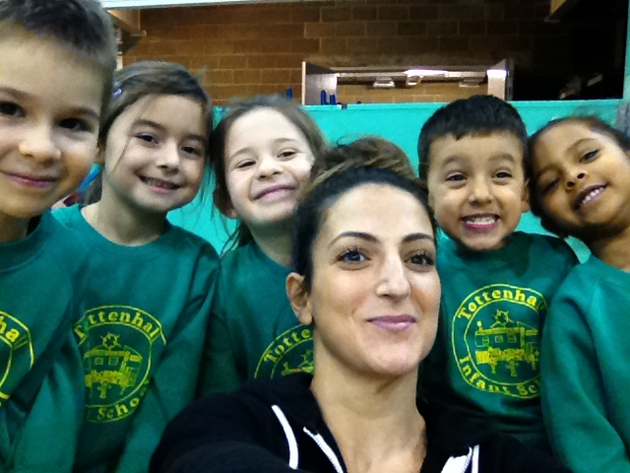

**Dance Festival 2016**

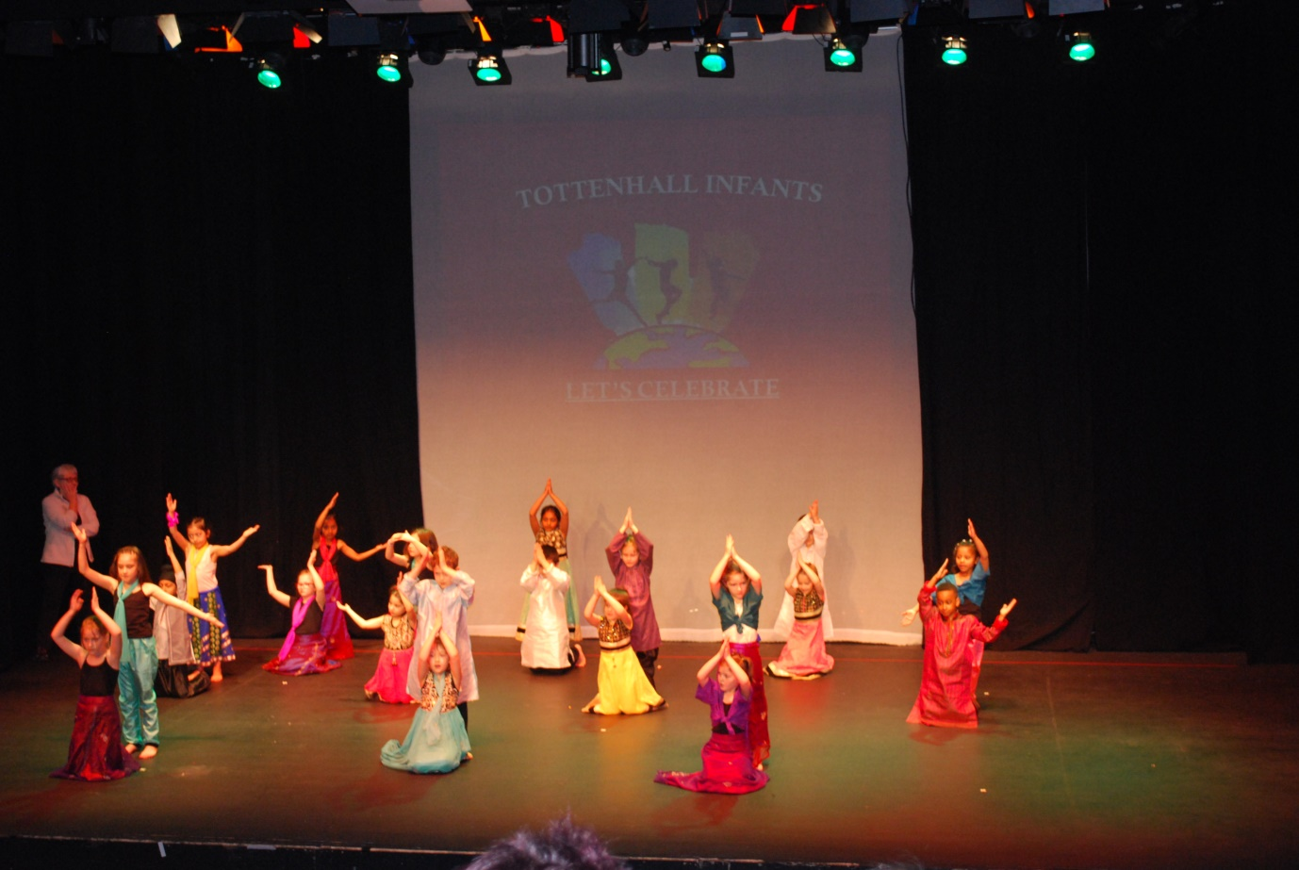

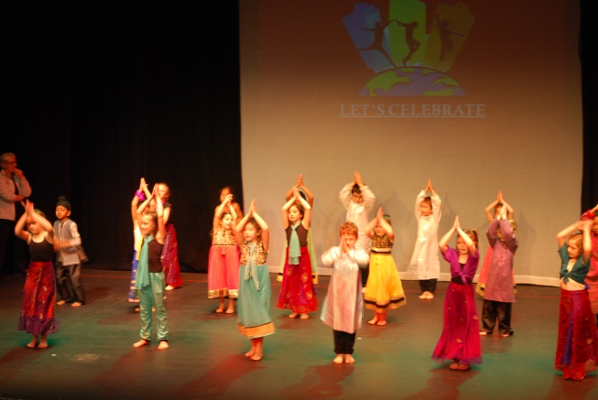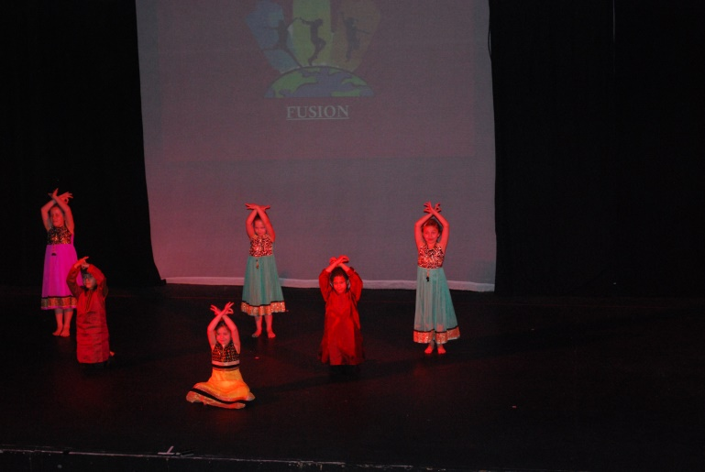

**Virtual Challenges:**

**Olympic Ring Jump Hoop Challenge**

‘*This half term it was the Olympic Ring Jump Hoop challenge:-"How many times can a Paralympic team of 7 athletes jump a ring  in 30secs,".....well* ***Tottenhall's KS1 team*** *jumped into the lead with 365.’* - Enfield PE Team

See more at: <http://www.enfieldpeteam.co.uk/news/18760/virtual-olympic-ring-challenges#sthash.6q5wukpe.dpuf>

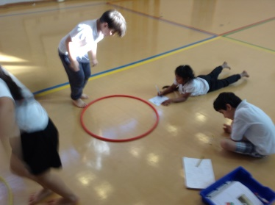 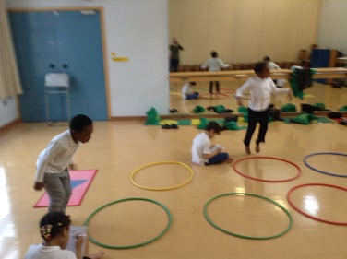 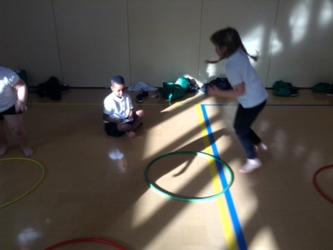

**Scoring a Basket**

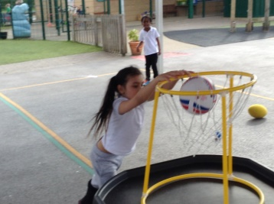 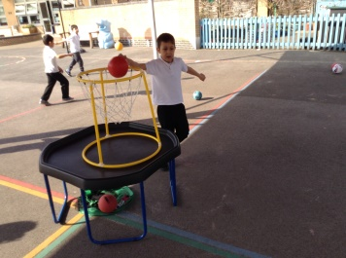 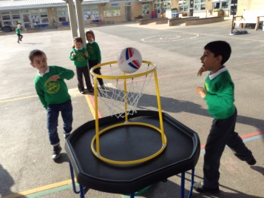

**Lea Valley Athletics Centre**

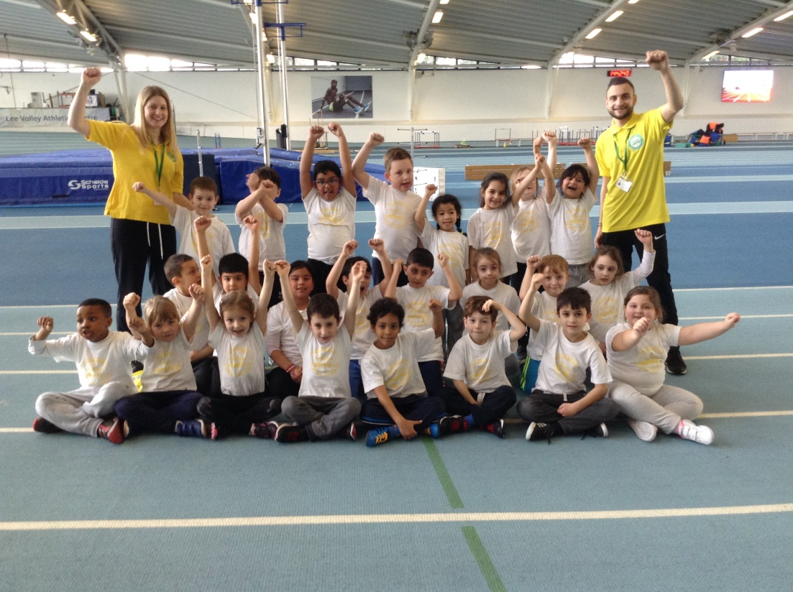

**How you can help develop your child’s physical education**Taking an interest, offering encouragement and participating in physical activities with your child are the best ways to keep them involved and interested. This will also help to develop your child’s confidence and self-esteem.

Always be ready to encourage your child whenever they experience difficulty with sports or other physical activities. Giving praise for effort, when your child has done their best is as important as praise for being the best!

If your child expresses an interest in a particular activity you could denlop it further by joining a local club.

**Everybody active in Enfield**  
This website has lots of information about sports clubs and classes for children and adults in Enfield in the local community and promotes all of the local sporting events – [www.enfield.gov.uk/sport](http://www.enfield.gov.uk/sport)